SQL QUERYING

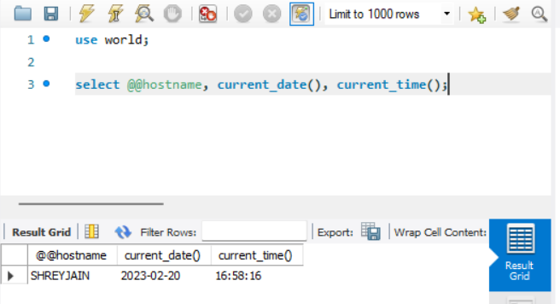

**QUESTION 1 :** SELECT * FROM country;

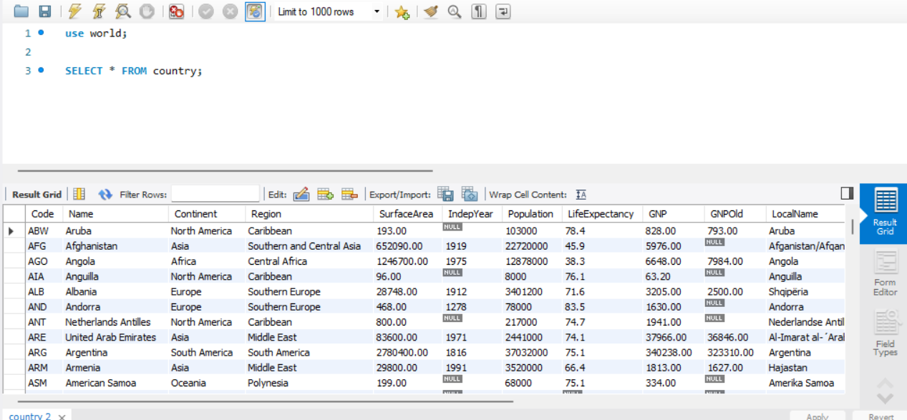

**QUESTION 2:** SELECT Name AS country FROM country WHERE Population > 100000000;

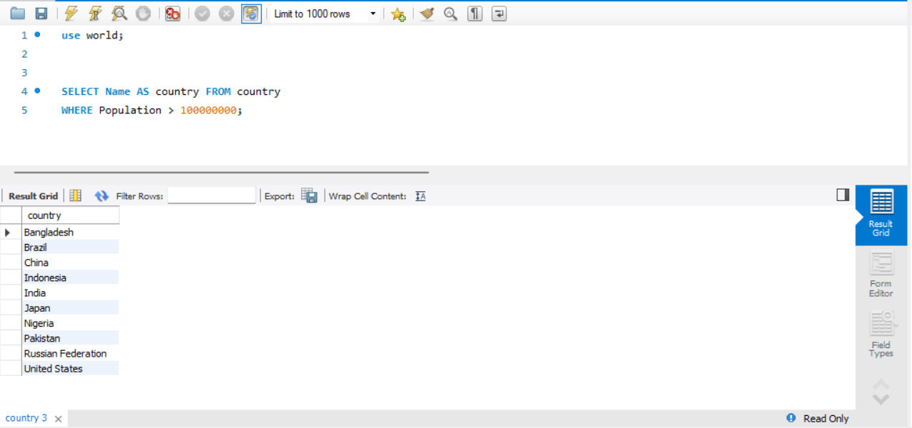

**QUESTION 3:** SELECT Name, Population/SurfaceArea AS Density FROM country LIMIT 5;

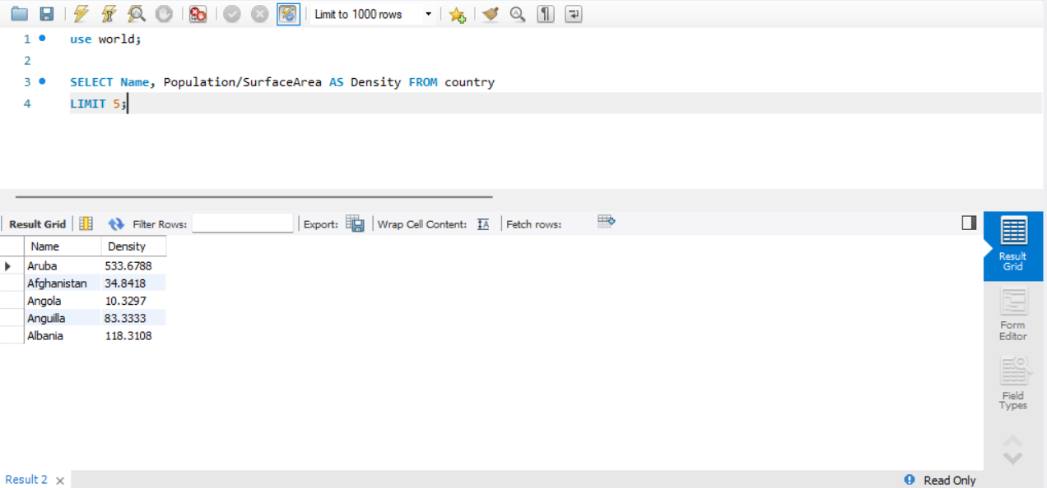

**QUESTION 4:** SELECT Name FROM country WHERE Name LIKE ‘S%’;

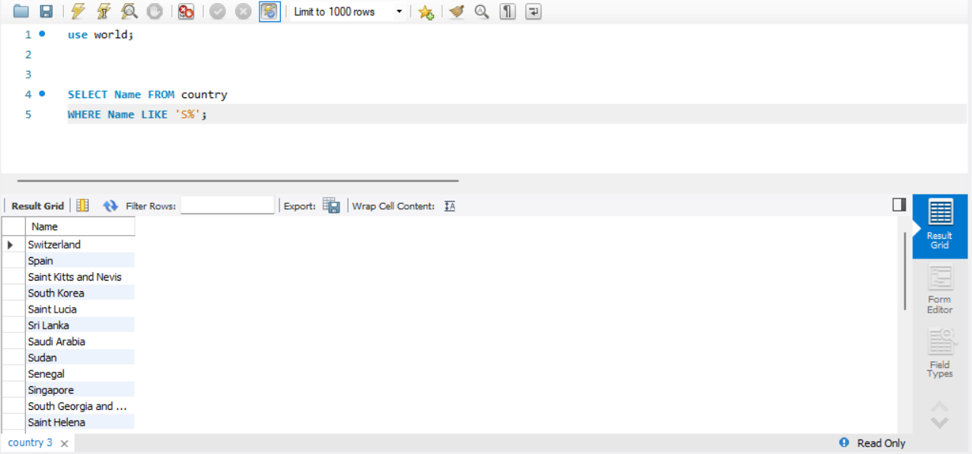

**QUESTION 5:** SELECT Name, Population FROM country WHERE Continent IN (‘Europe’,’Asia’) OR Name LIKE ‘S%’ LIMIT 5;

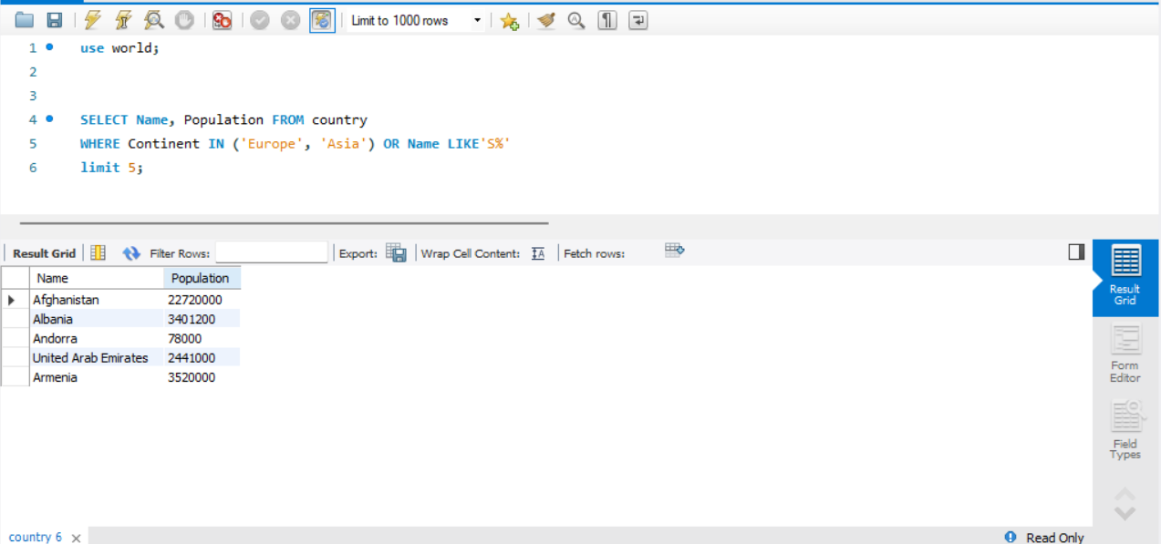

**QUESTION 6:** SELECT Name, LifeExpectancy FROM country WHERE LifeExpectancy BETWEEN 50 AND 80;

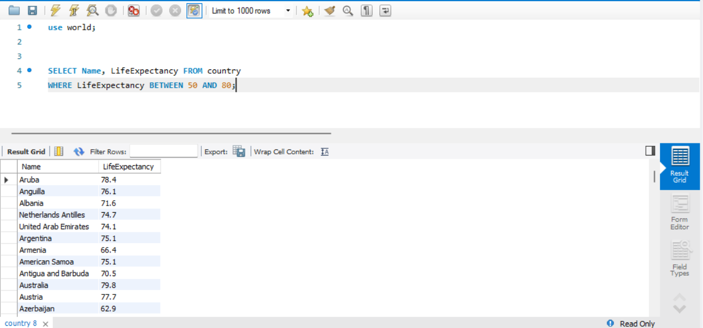

**QUESTION 7:** SELECT DISTINCT GovernmentForm FROM country;

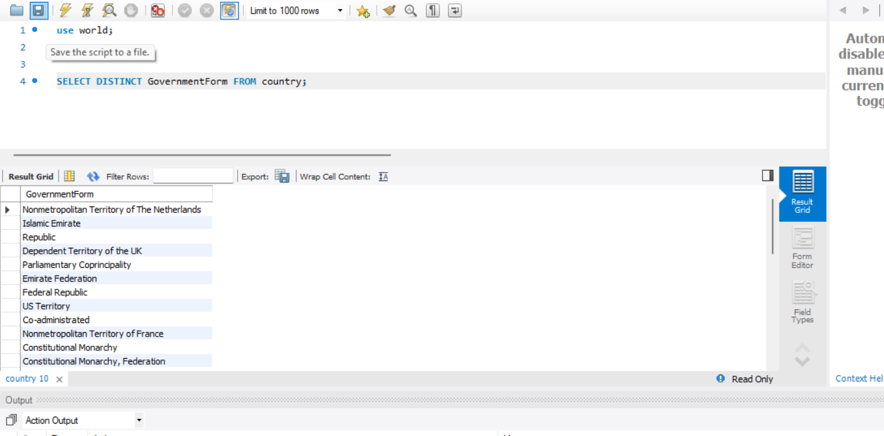

**QUESTION 8:** SELECT CONCAT(Name, ’ - ’, Code) FROM country;

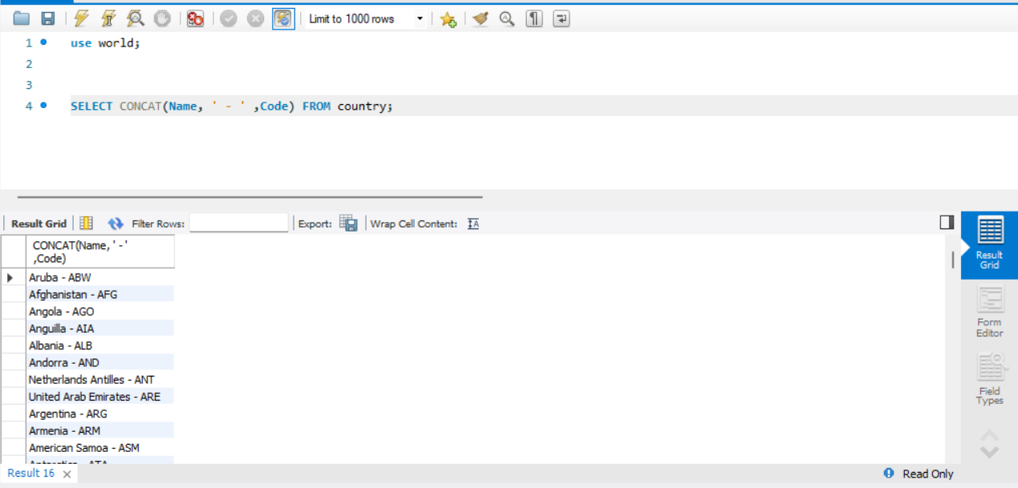

**QUESTION 9:**

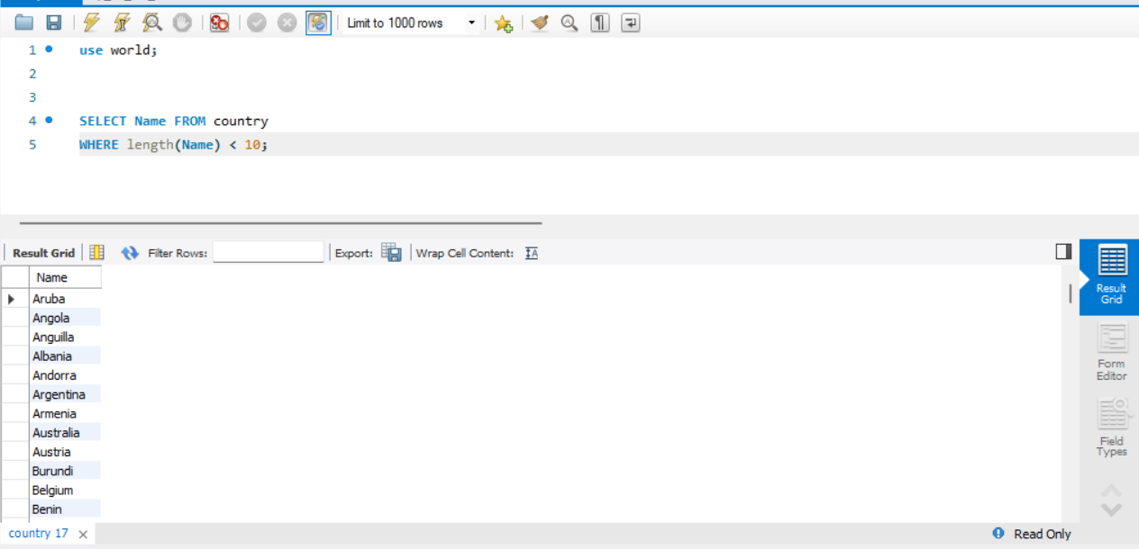

**QUESTION 10:** SELECT Name FROM country WHERE Name NOT IN (‘Aruba’,’Angola’,’Anguilla’,’Albania’,’Andorra’);

